CPE301 – SPRING 2019

MIDTERM II

Student Name: Carlos D. Zuniga

Student #:2000783713

Student Email: zunigc2@unlv.nevada.edu

Primary Github address: https://github.com/cdaniel64/blassen

Directory: Midterms/Midterm2

1. **COMPONENTS LIST AND CONNECTION BLOCK DIAGRAM w/ PINS**

List of Components used

Atmega328P

APDS9960

ESP-01

Breadboard

Power Supply

Jumper Cables

1. **INITIAL/MODIFIED/DEVELOPED CODE OF TASK 1/A**

**MAIN C Code**

#define *F_CPU* 16000000UL //initialize CPU

#include <avr/io.h> //include avr library

#include <util/delay.h> //include delay library

#include <stdio.h> //include stdio library

#include "i2c_master.h" //include i2c communication branch

#include "uart.h" //include uart library branch

#include "apds.h" //include apds library branch

#define BAUD 9600 //define transmission rate

#define BRGVAL (*F_CPU*/16/BAUD) - 1

#ifndef APDS_H

#define APDS_H

#include <avr/io.h>

#include "i2c_master.h"

#include "apds.h"

#define APDS_WRITE (0x39 << 1) | 0

#define APDS_READ (0x39 << 1) | 1

// Debug process as follows

// APDS-9960 I2C address

#define APDS9960_I2C_ADDR 0x39

//Error code for returned values

#define ERROR 0xFF

//Acceptable device IDs

#define APDS9960_ID_1 0xAB

#define APDS9960_ID_2 0x9C

//Misc parameters

#define FIFO_PAUSE_TIME 30 // Wait period (ms) between FIFO reads

//APDS-9960 Reg address

#define APDS9960_ENABLE 0x80

#define APDS9960_ATIME 0x81

#define APDS9960_WTIME 0x83

#define APDS9960_PERS 0x8C

#define APDS9960_CONFIG1 0x8D

#define APDS9960_PPULSE 0x8E

#define APDS9960_CONFIG2 0x90

#define APDS9960_ID 0x92

#define APDS9960_RDATAL 0x96

#define APDS9960_RDATAH 0x97

#define APDS9960_GDATAL 0x98

#define APDS9960_GDATAH 0x99

#define APDS9960_BDATAL 0x9A

#define APDS9960_BDATAH 0x9B

#define APDS9960_POFFSET_UR 0x9D

#define APDS9960_POFFSET_DL 0x9E

#define APDS9960_CONFIG3 0x9F

//Bits

#define APDS9960_PON 0b00000001

#define APDS9960_AEN 0b00000010

#define APDS9960_PEN 0b00000100

#define APDS9960_WEN 0b00001000

#define APSD9960_AIEN 0b00010000

#define APDS9960_PIEN 0b00100000

#define APDS9960_GEN 0b01000000

#define APDS9960_GVALID 0b00000001

//On/Off definitions

#define OFF 0

#define ON 1

//Acceptable parameters for setMode

#define POWER 0

#define AMBIENT_LIGHT 1

//#define PROXIMITY

#define WAIT 3

#define AMBIENT_LIGHT_INT 4

#define ALL 7

//LED Drive values

#define LED_DRIVE_100MA 0

#define LED_DRIVE_50MA 1

#define LED_DRIVE_25MA 2

#define LED_DRIVE_12_5MA 3

//LED Boost values

#define LED_BOOST_100 0

#define LED_BOOST_150 1

#define LED_BOOST_200 2

#define LED_BOOST_300 3

//Default values

#define DEFAULT_ATIME 219 // 103ms

#define DEFAULT_WTIME 246 // 27ms

#define DEFAULT_PROX_PPULSE 0x87 // 16us, 8 pulses

#define DEFAULT_POFFSET_UR 0 // 0 offset

#define DEFAULT_POFFSET_DL 0 // 0 offset

#define DEFAULT_CONFIG1 0x60 // No 12x wait (WTIME)

#define DEFAULT_LDRIVE LED_DRIVE_100MA

#define DEFAULT_PGAIN PGAIN_4X

#define DEFAULT_AGAIN AGAIN_4X

#define DEFAULT_AILT 0xFFFF // Force interrupt for calibration

#define DEFAULT_AIHT 0

#define DEFAULT_PERS 0x11 // 2 consecutive prox or ALS for int.

#define DEFAULT_CONFIG2 0x01 // No saturation interrupts or LED boost

#define DEFAULT_CONFIG3 0 // Enable all photodiodes, no SAI

#define DEFAULT_GLDRIVE LED_DRIVE_100MA

#define DEFAULT_GWTIME GWTIME_2_8MS

void apds_init();

void readColor();

#endif

*FILE* str_uart = *FDEV_SETUP_STREAM*(uart_putchar, *NULL* , *_FDEV_SETUP_WRITE*);

char results[256];

void init_UART();

int uart_putchar( char c, *FILE* *stream);

int main(void){

*uint16_t* red = 0, green = 0, blue = 0;

i2c_init();

init_UART();

*stdout* = &str_uart;

apds_init();

*_delay_ms*(2000); //huge delays

*printf*("AT\r\n");

*_delay_ms*(5000); //huge delays

*printf*("AT+CWMODE=1\r\n");

*_delay_ms*(5000); //huge delays

*printf*("AT+CWJAP=\"Wifi\",\"Password\"\r\n");

while (1) {

*_delay_ms*(5000); //huge delays so we dont get data loss

*printf*("AT+CIPMUX=0\r\n");

*_delay_ms*(5000); //more huge delays

*printf*("AT+CIPSTART=\"TCP\",\"api.thingspeak.com\",80\r\n");

//setting up teamspeak

*_delay_ms*(5000);

readColor(&red, &green, &blue);

*printf*("AT+CIPSEND=104\r\n");

//preparing to connect to thingspeak

*printf*("GET https://api.thingspeak.com/update?api_key=TX0EL61BIR6SH2GO&field1=%05u&field2=%05u&field3=%05u\r\n", red, green, blue);

*_delay_ms*(5000);

}

}

void apds_init(){

*uint8_t* setup;

i2c_readReg(APDS_WRITE, APDS9960_ID, &setup,1);

if(setup != APDS9960_ID_1) while(1);

setup = 1 << 1 | 1<<0 | 1<<3 | 1<<4;

i2c_writeReg(APDS_WRITE, APDS9960_ENABLE, &setup, 1);

setup = DEFAULT_ATIME;

i2c_writeReg(APDS_WRITE, APDS9960_ATIME, &setup, 1);

setup = DEFAULT_WTIME;

i2c_writeReg(APDS_WRITE, APDS9960_WTIME, &setup, 1);

setup = DEFAULT_PROX_PPULSE;

i2c_writeReg(APDS_WRITE, APDS9960_PPULSE, &setup, 1);

setup = DEFAULT_POFFSET_UR;

i2c_writeReg(APDS_WRITE, APDS9960_POFFSET_UR, &setup, 1);

setup = DEFAULT_POFFSET_DL;

i2c_writeReg(APDS_WRITE, APDS9960_POFFSET_DL, &setup, 1);

setup = DEFAULT_CONFIG1;

i2c_writeReg(APDS_WRITE, APDS9960_CONFIG1, &setup, 1);

setup = DEFAULT_PERS;

i2c_writeReg(APDS_WRITE, APDS9960_PERS, &setup, 1);

setup = DEFAULT_CONFIG2;

i2c_writeReg(APDS_WRITE, APDS9960_CONFIG2, &setup, 1);

setup = DEFAULT_CONFIG3;

i2c_writeReg(APDS_WRITE, APDS9960_CONFIG3, &setup, 1);

}

void readColor(*uint16_t* *red, *uint16_t* *green, *uint16_t* *blue){

*uint8_t* redl, redh;

*uint8_t* greenl, greenh;

*uint8_t* bluel, blueh;

i2c_readReg(APDS_WRITE, APDS9960_RDATAL, &redl, 1);

i2c_readReg(APDS_WRITE, APDS9960_RDATAH, &redh, 1);

i2c_readReg(APDS_WRITE, APDS9960_GDATAL, &greenl, 1);

i2c_readReg(APDS_WRITE, APDS9960_GDATAH, &greenh, 1);

i2c_readReg(APDS_WRITE, APDS9960_BDATAL, &bluel, 1);

i2c_readReg(APDS_WRITE, APDS9960_BDATAH, &blueh, 1);

*red = redh << 8 | redl;

*green = greenh << 8 | greenl;

*blue = blueh << 8 | bluel;

}

void init_UART(void){

//Set baud rate

*uint16_t* baud_rate = BRGVAL;

UBRR0H = baud_rate >> 8;

UBRR0L = baud_rate & 0xFF;

//Enable receiver and transmitter

UCSR0B = ( 1 <<RXEN0)|( 1 <<TXEN0);

// Set frame format: 8data, 1stop bit

UCSR0C = (3 <<UCSZ00);

}

int uart_putchar(char c, *FILE* *stream){

//wait until buffer empty

while ( !( UCSR0A & ( 1 <<UDRE0)) );

//Put data into buffer

UDR0 = c;

return 0;

}

**I2C CODE**

#ifndef F_CPU //initialization of CPU

#define F_CPU 16000000UL

#endif

#include <avr/io.h> //addition of common libraries

#include <util/twi.h>

#include "i2c_master.h" //callout library of i2c master

#define F_SCL 100000UL // SCL frequency

#define Prescaler 1

#define TWBR_val ((((F_CPU / F_SCL) / Prescaler) - 16 ) / 2)

void i2c_init(void)

{

TWBR = (*uint8_t*)TWBR_val;

}

*uint8_t* i2c_start(*uint8_t* address)

{

// reset TWI control register

TWCR = 0;

// transmit START condition

TWCR = (1<<TWINT) | (1<<TWSTA) | (1<<TWEN);

// wait for end of transmission

while( !(TWCR & (1<<TWINT)) );

// check if the start condition was transmitted

if((TWSR & 0xF8) != *TW_START*){ return 1; }

// load slave address into data register

TWDR = address;

// start transmission of address

TWCR = (1<<TWINT) | (1<<TWEN);

// wait for end of transmission

while( !(TWCR & (1<<TWINT)) );

// check if the device has READ / WRITE mode

*uint8_t* twst = *TW_STATUS* & 0xF8;

if ( (twst != *TW_MT_SLA_ACK*) && (twst != *TW_MR_SLA_ACK*) ) return 1;

return 0;

}

*uint8_t* i2c_write(*uint8_t* data)

{

// load data into data register

TWDR = data;

// start transmission of data

TWCR = (1<<TWINT) | (1<<TWEN);

// wait for end of transmission

while( !(TWCR & (1<<TWINT)) );

if( (TWSR & 0xF8) != *TW_MT_DATA_ACK* ){ return 1; }

return 0;

}

*uint8_t* i2c_read_ack(void)

{

// start TWI module and acknowledge data @ reception

TWCR = (1<<TWINT) | (1<<TWEN) | (1<<TWEA);

// wait for end of transmission

while( !(TWCR & (1<<TWINT)) );

// return received data from TWDR

return TWDR;

}

*uint8_t* i2c_read_nack(void)

{

// start receiving without acknowledging reception

TWCR = (1<<TWINT) | (1<<TWEN);

// wait for end of transmission

while( !(TWCR & (1<<TWINT)) );

return TWDR;

}

*uint8_t* i2c_transmit(*uint8_t* address, *uint8_t*\* data, *uint16_t* length)

{

if (i2c_start(address | I2C_WRITE)) return 1;

for (*uint16_t* i = 0; i < length; i++)

{

if (i2c_write(data[i])) return 1;

}

i2c_stop();

return 0;

}

*uint8_t* i2c_receive(*uint8_t* address, *uint8_t*\* data, *uint16_t* length)

{

if (i2c_start(address | I2C_READ)) return 1;

for (*uint16_t* i = 0; i < (length-1); i++)

{

data[i] = i2c_read_ack();

}

data[(length-1)] = i2c_read_nack();

i2c_stop();

return 0;

}

*uint8_t* i2c_writeReg(*uint8_t* devaddr, *uint8_t* regaddr, *uint8_t*\* data, *uint16_t* length)

{

if (i2c_start(devaddr | 0x00)) return 1;

i2c_write(regaddr);

for (*uint16_t* i = 0; i < length; i++)

{

if (i2c_write(data[i])) return 1;

}

i2c_stop();

return 0;

}

*uint8_t* i2c_readReg(*uint8_t* devaddr, *uint8_t* regaddr, *uint8_t*\* data, *uint16_t* length)

{

if (i2c_start(devaddr)) return 1;

i2c_write(regaddr);

if (i2c_start(devaddr | 0x01)) return 1;

for (*uint16_t* i = 0; i < (length-1); i++)

{

data[i] = i2c_read_ack();

}

data[(length-1)] = i2c_read_nack();

i2c_stop();

return 0;

}

void i2c_stop(void)

{

// transmit STOP condition when it is met

TWCR = (1<<TWINT) | (1<<TWEN) | (1<<TWSTO);

}

**UART Code**

#include <stdio.h> //initialize library

#include <avr/io.h>

#include <avr/interrupt.h>

#include "uart.h" //h.file

void init_UART(void){

//Set baud rate

*uint16_t* baud_rate = BRGVAL;

UBRR0H = baud_rate >> 8;

UBRR0L = baud_rate & 0xFF;

//Enable receiver and transmitter

UCSR0B = ( 1 <<RXEN0)|( 1 <<TXEN0);

// Set frame format: 8data, 1stop bit

UCSR0C = (3 <<UCSZ00);

}

int uart_putchar(char c, *FILE* *stream){

//wait until buffer empty

while ( !( UCSR0A & ( 1 <<UDRE0)) );

//Put data into buffer

UDR0 = c;

return 0;

}

**APDS code**

#include <avr/io.h>

#include "i2c_master.h"

#include "apds.h"

//initialization and processing of light sensing capabilities

void apds_init(){

*uint8_t* setup;

i2c_readReg(APDS_WRITE, APDS9960_ID, &setup,1);

if(setup != APDS9960_ID_1) while(1);

setup = 1 << 1 | 1<<0 | 1<<3 | 1<<4;

i2c_writeReg(APDS_WRITE, APDS9960_ENABLE, &setup, 1);

setup = DEFAULT_ATIME;

i2c_writeReg(APDS_WRITE, APDS9960_ATIME, &setup, 1);

setup = DEFAULT_WTIME;

i2c_writeReg(APDS_WRITE, APDS9960_WTIME, &setup, 1);

setup = DEFAULT_PROX_PPULSE;

i2c_writeReg(APDS_WRITE, APDS9960_PPULSE, &setup, 1);

setup = DEFAULT_POFFSET_UR;

i2c_writeReg(APDS_WRITE, APDS9960_POFFSET_UR, &setup, 1);

setup = DEFAULT_POFFSET_DL;

i2c_writeReg(APDS_WRITE, APDS9960_POFFSET_DL, &setup, 1);

setup = DEFAULT_CONFIG1;

i2c_writeReg(APDS_WRITE, APDS9960_CONFIG1, &setup, 1);

setup = DEFAULT_PERS;

i2c_writeReg(APDS_WRITE, APDS9960_PERS, &setup, 1);

setup = DEFAULT_CONFIG2;

i2c_writeReg(APDS_WRITE, APDS9960_CONFIG2, &setup, 1);

setup = DEFAULT_CONFIG3;

i2c_writeReg(APDS_WRITE, APDS9960_CONFIG3, &setup, 1);

}

void readColor(*uint16_t* *red, *uint16_t* *green, *uint16_t* *blue){

*uint8_t* redl, redh;

*uint8_t* greenl, greenh;

*uint8_t* bluel, blueh;

i2c_readReg(APDS_WRITE, APDS9960_RDATAL, &redl, 1);

i2c_readReg(APDS_WRITE, APDS9960_RDATAH, &redh, 1);

i2c_readReg(APDS_WRITE, APDS9960_GDATAL, &greenl, 1);

i2c_readReg(APDS_WRITE, APDS9960_GDATAH, &greenh, 1);

i2c_readReg(APDS_WRITE, APDS9960_BDATAL, &bluel, 1);

i2c_readReg(APDS_WRITE, APDS9960_BDATAH, &blueh, 1);

*red = redh << 8 | redl;

*green = greenh << 8 | greenl;

*blue = blueh << 8 | bluel;

}

1. **SCHEMATICS**

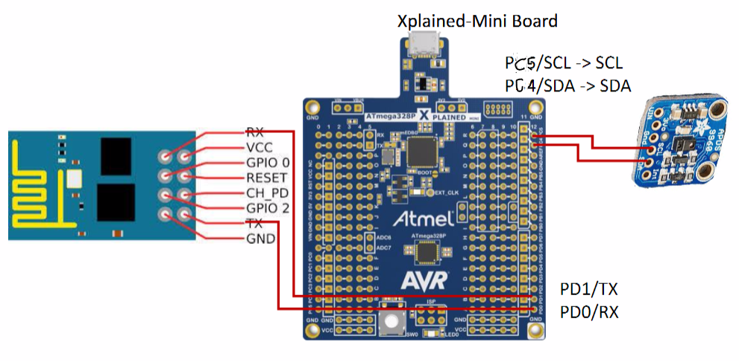

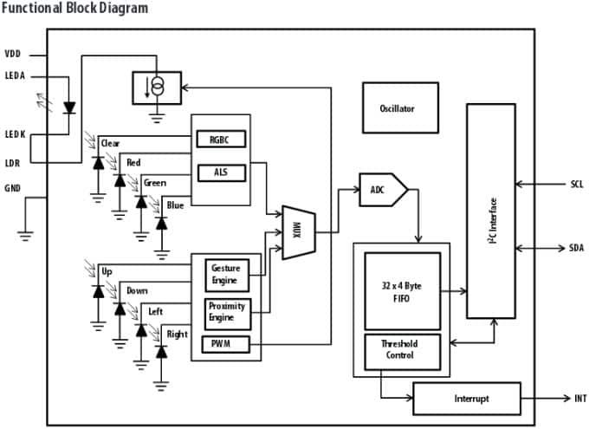

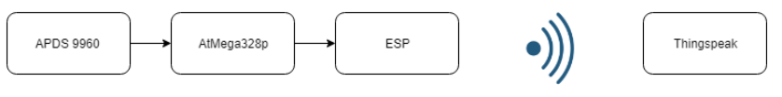

1. **SCREENSHOTS OF EACH TASK OUTPUT (ATMEL STUDIO OUTPUT)**

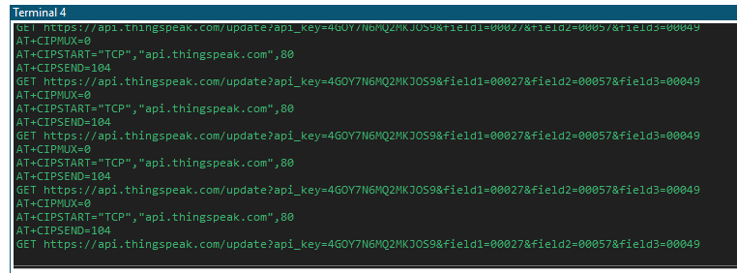

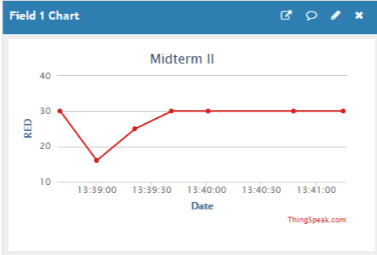

1. **SCREENSHOT OF EACH DEMO (BOARD SETUP)**

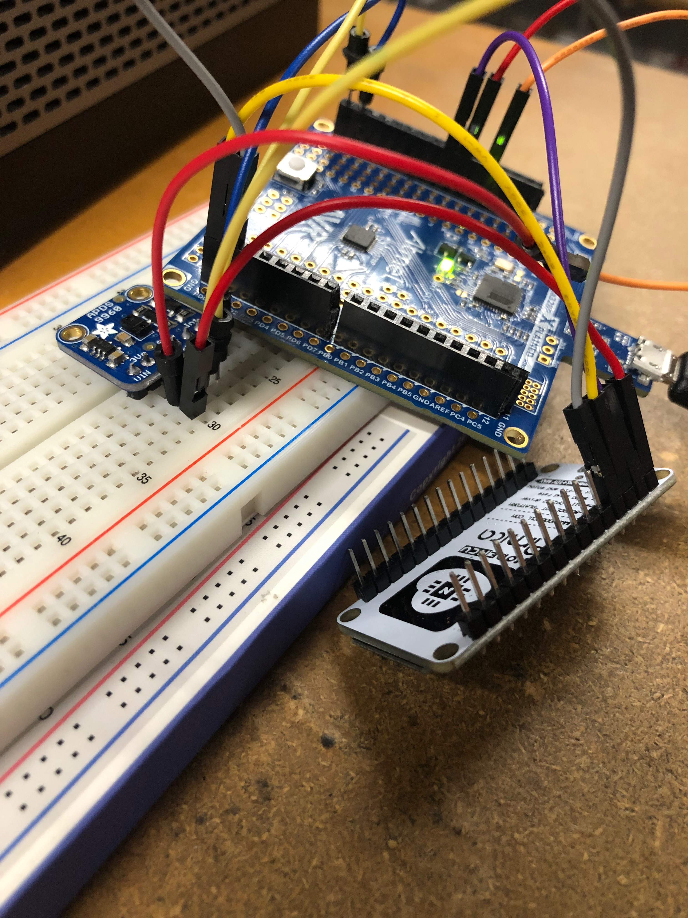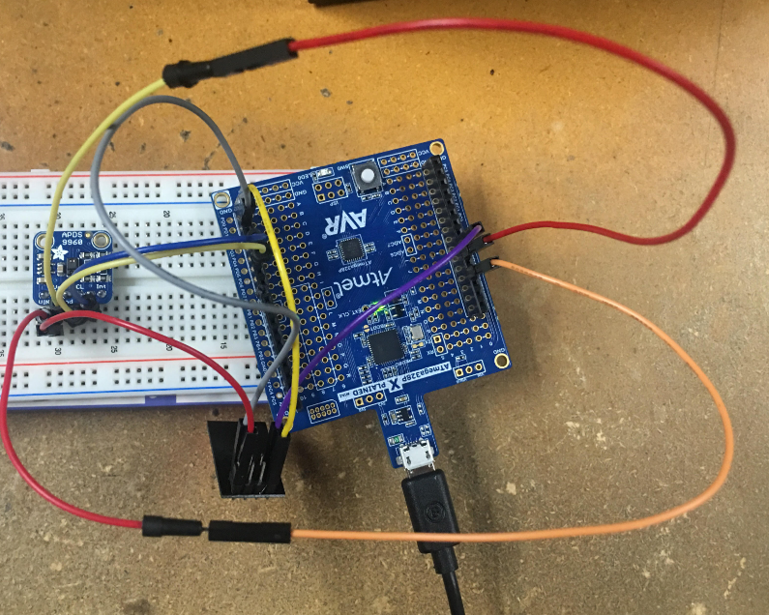

1. **VIDEO LINKS OF EACH DEMO**

[**https://youtu.be/Vc6xjqobPPA**](https://youtu.be/Vc6xjqobPPA)

1. **GITHUB LINK OF THIS DA**

<https://github.com/cdaniel64/blassen>

**Student Academic Misconduct Policy**

<http://studentconduct.unlv.edu/misconduct/policy.html>

“This assignment submission is my own, original work”.